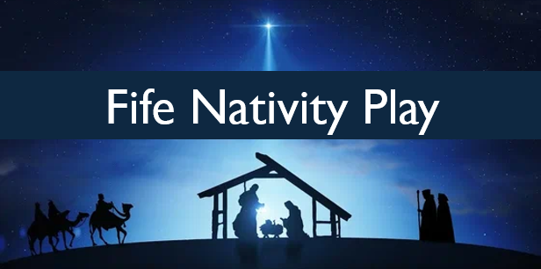
Adults - £11 Children under 16 - £5.50 Under 5’s - Free

7pm FRI 20th Dec
4pm SAT 21st Dec
7pm SAT 21st Dec
4pm SUN 22nd Dec
7pm SUN 22nd Dec

Tickets from www.wegottickets.com/FifeNativityPlay
Also, from ‘Fife Nativity’ Facebook page and www.fifenativity.org.uk
Venue
Lindores Abbey Distillery - Newburgh - Fife

